



**UNIVERSITY OF RWANDA**

**COLLEGE OF BUSINESS AND ECONOMICS**

**SCHOOL OF BUSINESS**

**BIT DEPARTMENT**

**LEVEL 3**

**GROUP 1**

**PROGRAMMING WITH CLIENT SERVER**

**TOPIC : Travel ticketing system**

**Names: DUSABE JOLLY 221003422**

**ISENGWE OLGA 221010320**

**IRADUKUNDA BENJAMIN 221018380**

**GISA BARERA EMERY 221008060**

**HAKUZIMANA CEDRICK 221017990**

**ISHIMWE LYDIA 221025238**

**Submission date: 10-9 -2023**



# Chapter 1: introduction

# TICKETING SYSTEM

Ticketing System is an vb based application that can be accessed throughout the Net and can be accessed by system users who has a net connection. This application will reserve(record)/cut tickets for customers the tickets and produce day to day reports. This ticket reservation system provides a way an admin and agent can access it. They are required to login to the system. Admin is one who have responsible for setting all requirements for agent to record ticket to customers for example admin has access to record company buses, directions and timely routes(journals) and also has to record agents, after agent has only one access to the system for cutting ticket to customers and print it as company like RITCO and HORIZON did. That means while developing our system we referenced that popular companies in Rwanda.

# PROBLEMS STATEMENT

Problem faced by the manual ticket system is long time taken to wait for tickets, sometimes you find when tickets have already been finished then that is loss of time, there is a problem of drivers stealing money from the company where you find there are clients without tickets and money is given to the driver, also there is another big problem where you find a bus going in different directions due to mixture of destinations places hence the delay of far passengers. As we saw all the above mentioned problems we thought of a solution.

# SOLUTIONS STATEMENT

The solution is making a system that will help passengers or clients reserve tickets and no spent time while waiting for tickets, this will prevent drivers from stealing money of the company thought paying them cash while on journeys, this also will help the company to satisfy passenger needs because this bus will express no stopping everywhere because all passengers will be having the same destination.

# GENERAL OBJECTIVE

The objective of the system is to make easy the ticket booking process and also this system will be giving update information that is not possible in manual.

Means our system will have the way to update routes(journey) before the time so that can be reserved by client before for example 2 days before

# SPECIFIC OBJECTIVES

System will provide way to reselve ticket before the time but not over the enternate but client came to our buss station and ask for reservation !

# FUNCTIONAL REQUIREMENTS

The functional requirements needed for the system to works properly as intended are as follows:

* The system should allow the user to Sign in and sign up.
* System will allow the agents to view the bus timely schedules.
* System will allow the agent to select needed journey for customers destination at certain time frame.
* The system will allow the user/agent to view information about a ready bus at that time and available sits.
* The system will allow the user/agent to print the ticket once the payment is made.
* The system will provide timely reports to the agency manager(admin)
* The system should allow admin(manager) to setting all requirement agent needed to record ticket to customer

Non function requirements

* Scalability: this is the ability of a computing process to be used or produced in a range of capabilities.
* Reliability: this is the quality of being trustworthy or of performing consistently well.
* Maintainability: this is the measure of ability of an item to be restored to a specified condition.
* Serviceability: this is the quality of being able to provide good service. ✓Utility: this is the state of being useful, profitable or beneficial ✓Security: this is state of being free from a danger or threat.
* Manageability: this is the capability of being managed and controlled.
* Data integrity: this is the accuracy and consistency of data stored in database.
* Regulatory: this is the giving of direction to an activity by setting rules and laws.
* Availability: this is the quality of being able to be used or obtained.
* Usability: this is the degree to which something is able or fit to be used.
* Interoperability: this is the ability of computer systems to make exchange and make use of information.

CHAPTER 2: **DATABASE**

**INTRODUCTION**

**This database will hold information of this system including customers information , ticket information users information and ticket information where every user of this system will have same access to database according to user type like admin,normal user…**

**ERD(Entity Relationship diagram)**

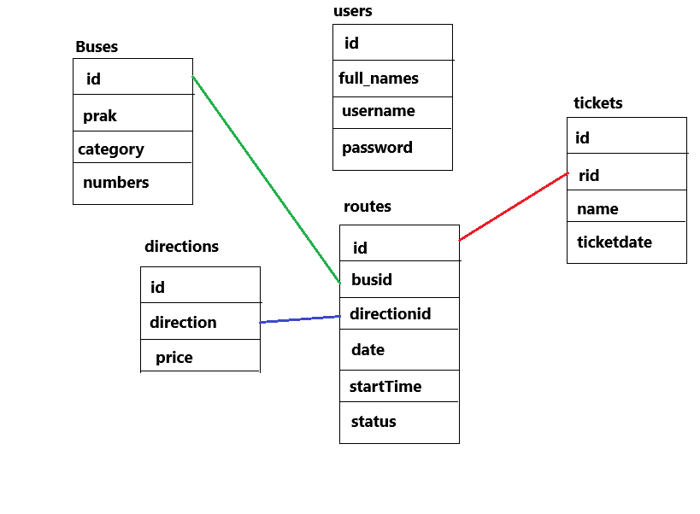

**We have only five table with that relationships, this means table have related each other as showen above**

**USE CASE DIAGRAM**

**Our use case diagram shows all main activities that will curied in the system user by user**

**As we have planned before we plan to have only two users manager(admin) and users(agents)**

**They have the following coresponding activities as diagram showen bellow.**

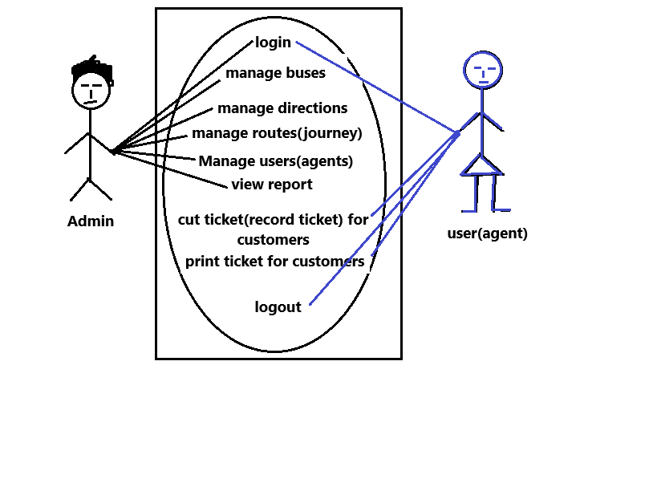

**We are going to explain table by table**

**DATA DICTIONALLY**

**1.table buses**

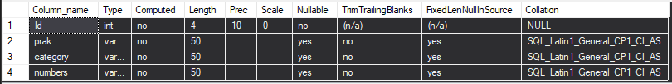

**2.table direction**

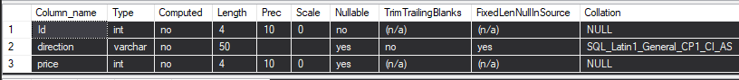

**3. table routes**

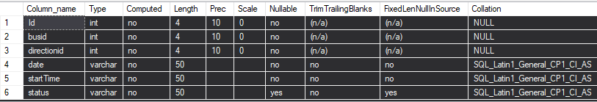

**4.table tickets**

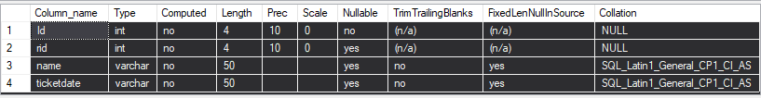

**5.table users**

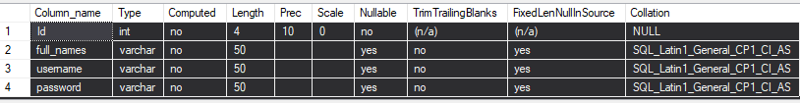

**TABLES IN THIS DATABASE**

**TABLE 1 : BUSES TABLE**

**This table will store bus information in system**

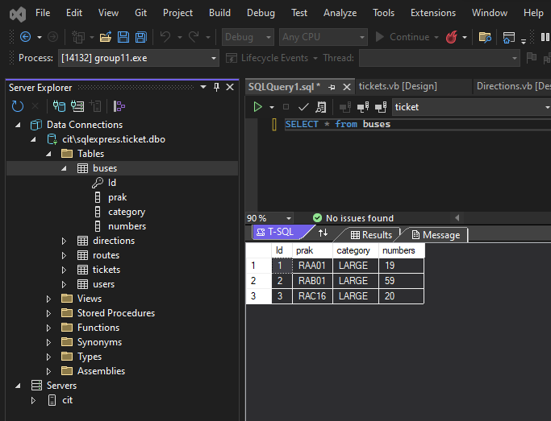

**TABLE 2 :ROUTES**

**This table will hold all routes with bus id as foreign key for table buss and direction id as foregn key in table directions**

**Means table routes(changes over the time) while direction table is all direction(destination our company goes)**

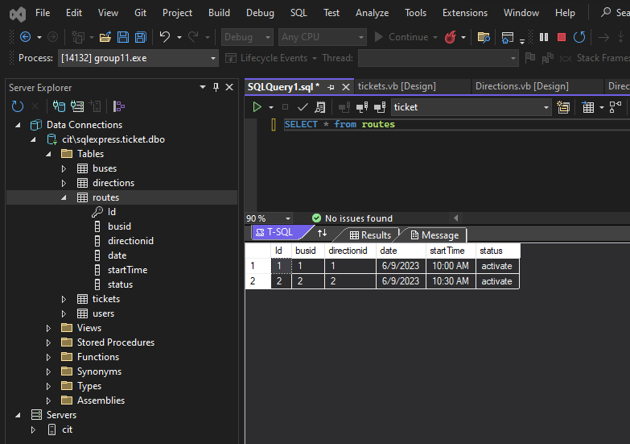

**Table 3: USERS**

**this table will store users information , it will help us in uses logins both admin and agents**

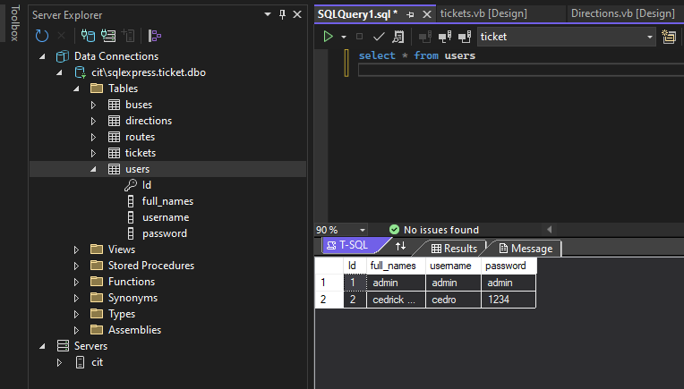

**Table 4: TICKETS TABLES**

**This table will store ticket information as showed bellow this table have customer id as indicatind who by ticket and route id indicating direction of the jurney**

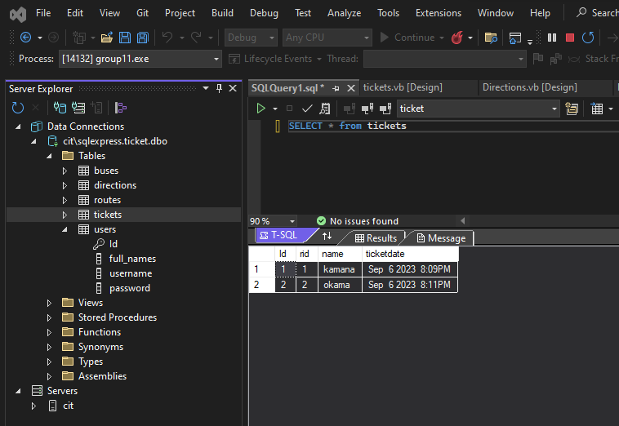

**Table 5: DIRECTIONS TABLE**

**This table will holds direction in system**

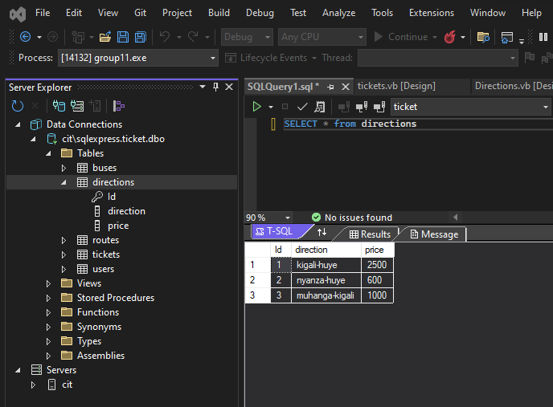

**CAPTER 3: VB.NET APPLICATION**

**INTRODUCTION**

This system used by two different users including admin and agent(normal users) day to day workers and every user will have their own controls according to its type.

Admin will allowed to use system throuth the login form and his cridatios is hard coded (username: admin and password:admin ) and do different activities including the following

* Admin can view different statistics in numbers as shown in bellow screenshoot after login where there is number of buses in company, number of users,number of directions in company,…
* Admin can add buses

As menus showed admin have access to add and modify campany buses which used to assing to any jurney(route) before agent/user cut ticket to clients()customers.

* Admin can add and modify company directions and give amount of many to that directions
* Admin can add/modify jurney(route) to make it clear route is setted over the time but direction is fixed , means while we create route(journey) admin need to assign direction,time,buss to that route in order to make agent easy for cut ticket to client
* Admin can also add and modify agents/user and give username and password
* Admin can also view report for amount and ticket buyed day to day

**User (agent)**

User/ agent is one who has responsible to cut ticket to any customers as we know for any travering agency(Horizon,ritco,…)

He can do the following in our system

* Firstly he/she have to login with cridentos given by admin
* After login he has to search route available jurnel added by admin add record customer ticket by adding that route id coresponding to customer (route) he/she wishe after record it the system will display ticket information and print it !

By trying to summerising user access

**ADMIN CAN**

-login

-view different statistics

-add buses

-add directions

-add route

-add and modify the users

-view reports

-logout

**AGENT CAN**

-login

-record ticket

-print it (ticket)

-logout

We are going to show same screen shoot for each user by user

Both users have to first log in

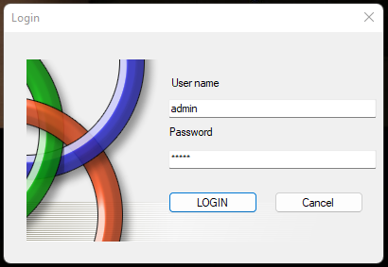

This login form is for both agent/user and admin remind that agent is added by admin means admin can login first to add that user(agent) and after user can also login into system after being added by admin.

Admin cridatios is setted in database heard coded(username:admin,password:admin)

**ADMIN ACCOUNT**

**as we said before admin can view different system statistics as showen bellow**

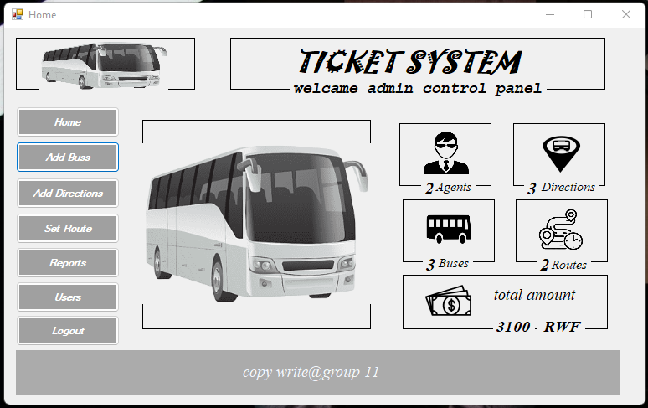

**He has to view different basic statistics like number of buses,number of direction…..**

**After add for axample bus the statistics changed also and updated to real database numbers**

**Admin can add buses**

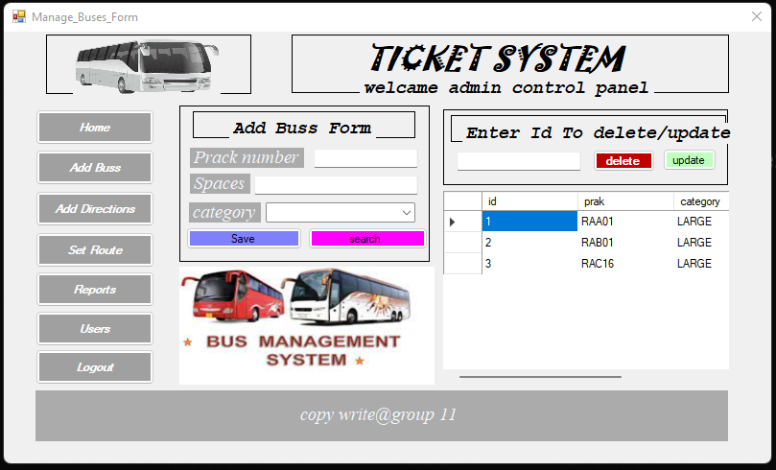

Can add destination(direction) and it prices

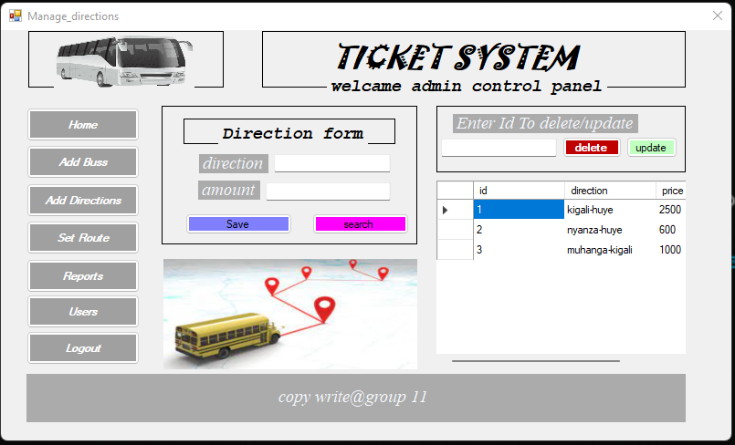

Admin can add and modify company directions and give amount of many to that directions

Can view ,update and delete routes

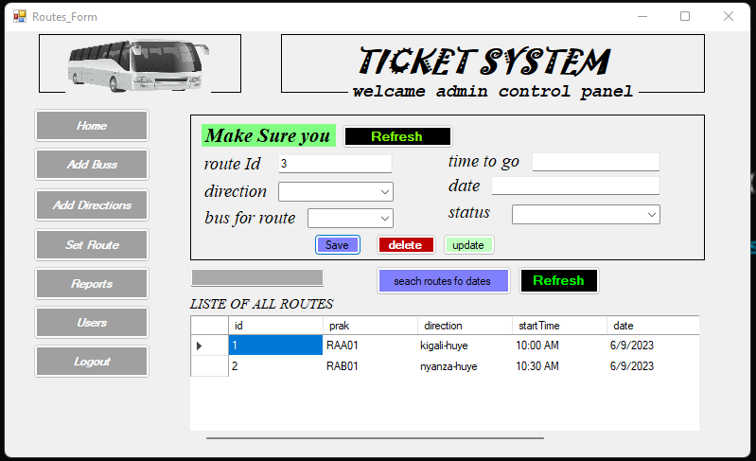

At this point admin has access to set route or journey as we have said above this route is changed over the time means when he set it and routes expires by sold out all tickets corresponding to that routes it became the expires because there is no more tickets buyed any more because all tickets corresponding to that route has been sold out

**CAN VIEW TICKETS AND REPORTS**

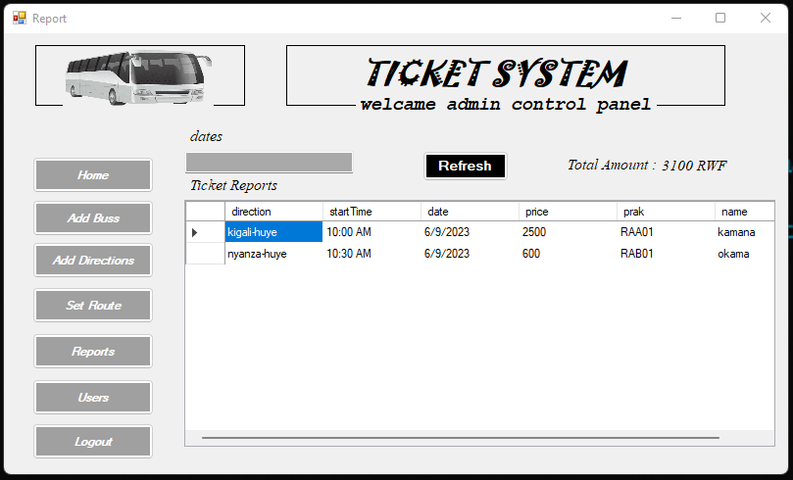

On this stage admin has access to view report on choice day what he do is to specify which date he want to make reports and system generate reports on that date and calculate total amount received from that date.

CAN ADD AND MODIFY USERS/AGENTS

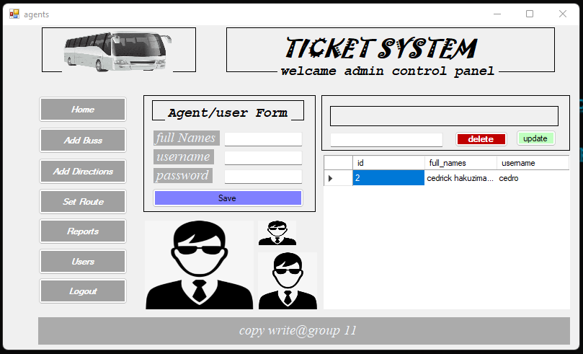

Admin can add agents and give them passwords that will be used while they login into systems

**NORMAL USER/AGENT**

After login normal user can cut tickets

Before agent view tickets prices on all directions we have

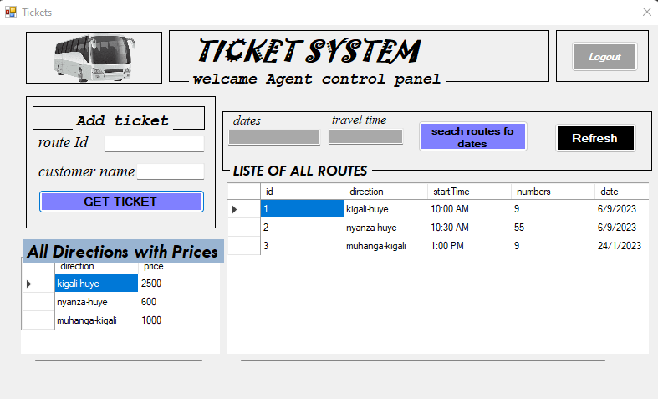

Agent after making successful login will directly have access to cut ticket but before he/she must be able to search appropriate route corresponding to the customer wishes based on dates and time.

After he has to enter that route id in the form and customer name and click on get ticket and system will directly generate that ticket information and click on print ticket to be able to print it and give it to client as shown bellow

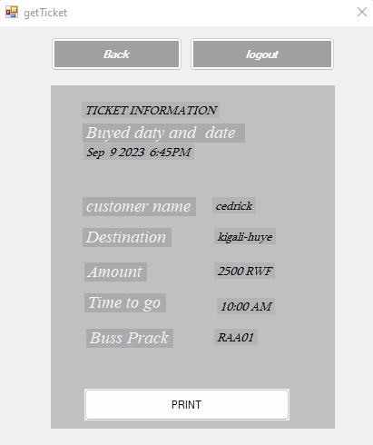

Print ticket after receiving ticket id as we have said we have to enter it and press get for getting ticket information and print it

! but one of the quality of our ststem does not torerate mistakes ! because it generate correct messages for example you can and route id does not exist and system will generate correct message on that issue

LITERATURE REVIEW

Ticketing systems have gained significant popularity as a convenient and efficient method for travelers to plan and book their trips. Traditional ticketing systems developed using SQL Server and VB.NET offer several advantages for customers. These benefits include enhanced convenience, time savings, and increased control over the booking process. Customers can make informed decisions by accessing real-time updates and comparing prices and options from various service providers.

Furthermore, ticketing systems developed with SQL Server and VB.NET offer comprehensive information about different travel options, including detailed itineraries, pricing details, and safety measures. The implementation of these systems can streamline the booking process, reducing the reliance on manual procedures and potentially minimizing errors and waiting times.

However, it's important to acknowledge that there are certain potential drawbacks associated with ticketing systems. Customers may encounter issues related to the accuracy of information or technical difficulties while using the booking platform. Additionally, some individuals may prefer the personalized assistance provided by travel agents or opt for in-person ticket bookings due to personal preferences.

In summary, ticketing systems developed with SQL Server and VB.NET have emerged as a valuable tool for travelers, offering advantages such as convenience, time efficiency, and access to comprehensive travel information. Nonetheless, it is crucial for customers to be aware of the potential challenges and ensure their comfort with the chosen ticketing platform before finalizing their bookings.

Regarding the development of our own ticketing system, we utilized SQL Server and VB.NET as the core technologies for building a desktop-based application. In addition to these software components, we made use of other necessary tools and resources to create a robust and efficient ticketing solution.

By leveraging SQL Server and VB.NET, we were able to design a ticketing system that caters to the specific needs of our users while ensuring data integrity and performance in an on-premises environment.

*Referental projects(systems)*

*1.Ritco system*

*2.horizon system*